GAME DESIGN DOCUMENT

“Fun games are mindless, but challenging” – Megan Chua

Contents

|  |  |  |
| --- | --- | --- |
| [1 Game Overview](https://n-xovwktmtjsnaxyc2mwes2xu7pohqedmdm6zjw5q-2lu-script.googleusercontent.com/userCodeAppPanel)  [2 High Concept](https://n-xovwktmtjsnaxyc2mwes2xu7pohqedmdm6zjw5q-2lu-script.googleusercontent.com/userCodeAppPanel)  [3 Unique Selling Points](https://n-xovwktmtjsnaxyc2mwes2xu7pohqedmdm6zjw5q-2lu-script.googleusercontent.com/userCodeAppPanel)  [4 Competitors](https://n-xovwktmtjsnaxyc2mwes2xu7pohqedmdm6zjw5q-2lu-script.googleusercontent.com/userCodeAppPanel) / Similar Titles  5 [Synopsis](https://n-xovwktmtjsnaxyc2mwes2xu7pohqedmdm6zjw5q-2lu-script.googleusercontent.com/userCodeAppPanel)  [6 Game Objectives](https://n-xovwktmtjsnaxyc2mwes2xu7pohqedmdm6zjw5q-2lu-script.googleusercontent.com/userCodeAppPanel)  [7 Game Rules](https://n-xovwktmtjsnaxyc2mwes2xu7pohqedmdm6zjw5q-2lu-script.googleusercontent.com/userCodeAppPanel)  [8 Game Structure](https://n-xovwktmtjsnaxyc2mwes2xu7pohqedmdm6zjw5q-2lu-script.googleusercontent.com/userCodeAppPanel)  [9 Game Play](https://n-xovwktmtjsnaxyc2mwes2xu7pohqedmdm6zjw5q-2lu-script.googleusercontent.com/userCodeAppPanel)  [10 Players](https://n-xovwktmtjsnaxyc2mwes2xu7pohqedmdm6zjw5q-2lu-script.googleusercontent.com/userCodeAppPanel)  [10.1 Characters](https://n-xovwktmtjsnaxyc2mwes2xu7pohqedmdm6zjw5q-2lu-script.googleusercontent.com/userCodeAppPanel)  [10.2 States](https://n-xovwktmtjsnaxyc2mwes2xu7pohqedmdm6zjw5q-2lu-script.googleusercontent.com/userCodeAppPanel)  [11 NPC](https://n-xovwktmtjsnaxyc2mwes2xu7pohqedmdm6zjw5q-2lu-script.googleusercontent.com/userCodeAppPanel) Enemies  [12 Art](https://n-xovwktmtjsnaxyc2mwes2xu7pohqedmdm6zjw5q-2lu-script.googleusercontent.com/userCodeAppPanel)  [12.1 Setting](https://n-xovwktmtjsnaxyc2mwes2xu7pohqedmdm6zjw5q-2lu-script.googleusercontent.com/userCodeAppPanel)  [12.2 Level Design](https://n-xovwktmtjsnaxyc2mwes2xu7pohqedmdm6zjw5q-2lu-script.googleusercontent.com/userCodeAppPanel)  [12.3 Audio](https://n-xovwktmtjsnaxyc2mwes2xu7pohqedmdm6zjw5q-2lu-script.googleusercontent.com/userCodeAppPanel)  [13 Wish List](https://n-xovwktmtjsnaxyc2mwes2xu7pohqedmdm6zjw5q-2lu-script.googleusercontent.com/userCodeAppPanel)  14 Bibliography   |  | | --- | |  | | Game Development Team Members    PRODUCER  Megan Chua    PRODUCTION MANAGER  Megan Chua    PRODUCTION COORDINATOR  Megan Chua  GAME DESIGNERS  Megan Chua  SYSTEMS/IT COORDINATOR  Megan Chua  PROGRAMMERS  Megan Chua  TECHNICAL ARTISTS  Megan Chua  AUDIO ENGINEERS  Megan Chua  UX TESTERS  Megan Chua |

|  |
| --- |
|  |

# 1 Game Overview

**Title**: Happy Whale

**Platform**: PC Standalone

**Genre**: Fantasy, Side-Scroller

**Rating**: (10+) ESRB

**Target**: Casual gamer (aging from 12 - 30)

**Release date:** November 2019

**Publisher**: Chua Games

Happy Whale is a fantasy side-scroller game where the Player is a whale swimming through the colorful ocean, trying to avoid the evil jelly fish. The Player must dodge through the plethora of jelly fish while also obtaining the most amount of coins possible. In order to succeed, the Player must swim in between the spaces of the jelly fish and avoid the spikey coral at the bottom of the sea floor. There are three levels offered to the Player, all of which varying in difficulty. The easy level offers a steady-paced flow of jelly fish, while the medium level speeds up their movement. In the hardest level, the Player’s evil twin brother has made an appearance and is trying to prevent you from obtaining the coins. The Player must also avoid this evil whale in addition to the previous obstacles. Survive as long as possible and obtain the most amount of coins as possible!

# 2 High Concept

Happy Whale sets the Player in the deep colorful ocean where he/she must avoid all the incoming jelly fish and the dangerous coral at the bottom of the ocean. Jump and dodge between these obstacles and follow the trail of coins to get the maximum amount of points!

# 3 Unique Selling Points

* Colorful and unique artwork
* Varying difficulty
* Endless fun

# 4 Competitors / Similar Titles

Whale Trails, Flappy Bird

# 5 Synopsis

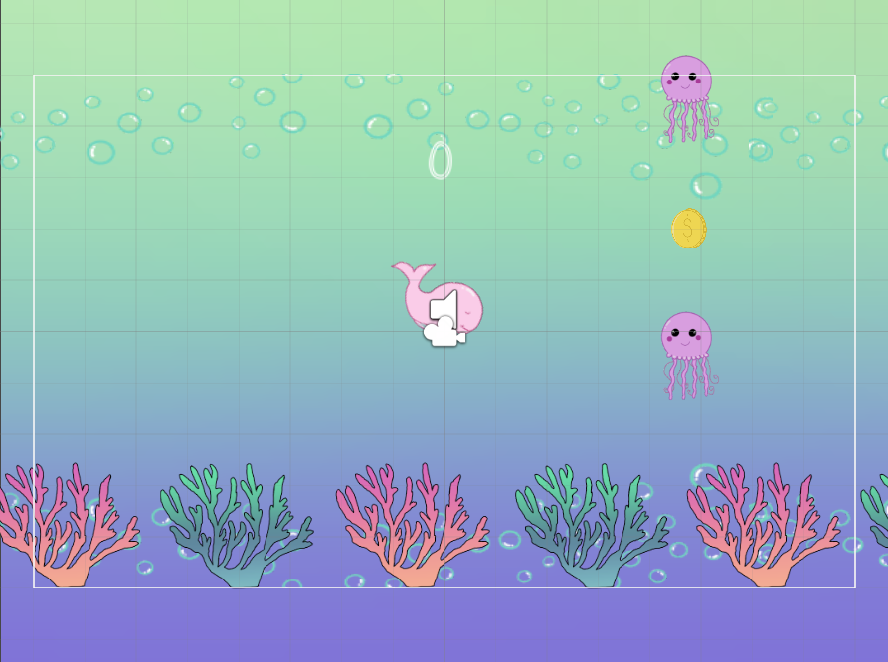You are swimming deep in the ocean and need to collect as many coins as possible to stay happy! Avoid the evil jelly fish and dangerous coral at the bottom of the sea. Swim through the jelly fish and survive for as long as possible!

# 6 Game Objectives

The objective of the game is to survive as long as possible and collect as many coins as possible.

# 7 Game Rules

The Player can jump through the jelly fish to obtain coins. In order to score points, the Player must swim in between the jelly fish.

# 8 Game Structure

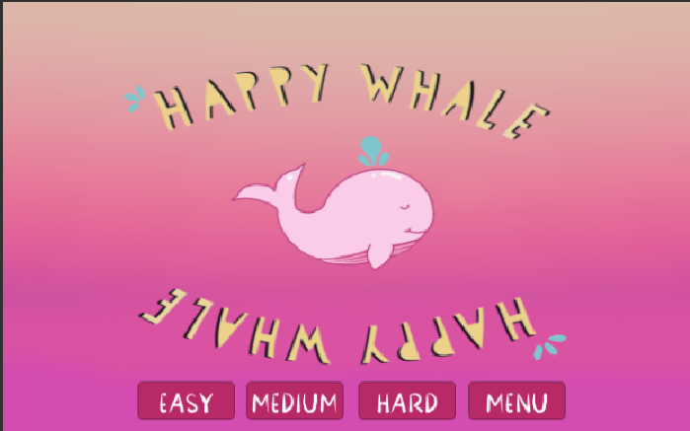Menu 🡪 Levels Menu 🡪 Start Game Screen 🡪 Game Play 🡪 Game Over Screen

# 9 Gameplay

Game Controls: Use “Space” button to make the whale jump.

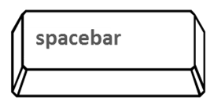

# 10 Players

Characters: The Player controls the main whale. The enemy jelly fish are spawned by the computer.

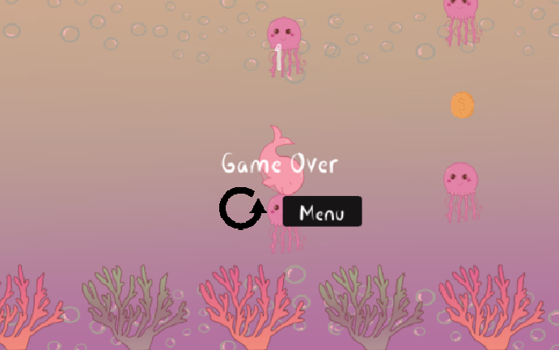Player States: Since the Player has the force of gravity working on it, it must be constantly moving in order to survive. The movement animation will cause the character to jump. The death animation stops the move animation of the whale.

# 11 NPC

The enemy jelly fish spawn off the screen and randomly shift across the y-axis. When the whale touches the jelly fish, the Player dies. The dangerous coral continuously spawn across the bottom of the screen.

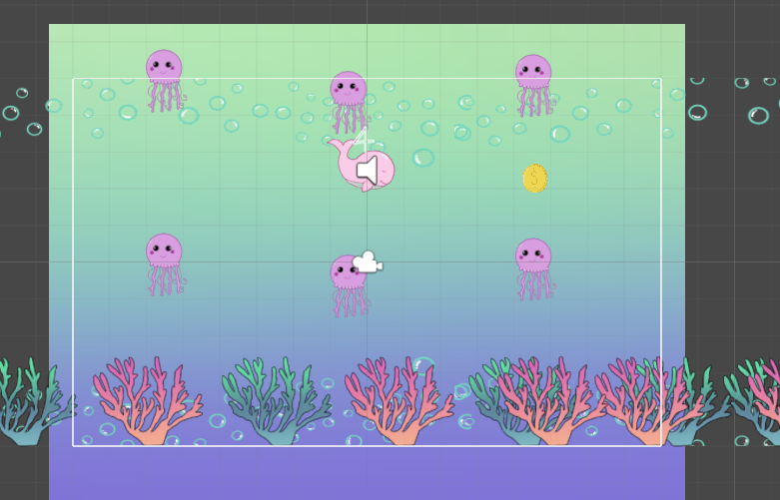

Jelly fish:

* Shift speed: 2 (easy), 5 (medium), 8 (hard)
* Spawn rate: 2.5 (easy), 1 (medium), 1 (hard)

The enemy stays at an idle position, just moving across the screen where it is spawned.

# 12 Art

Setting: The game takes place at the bottom of the ocean with coral and bubbles at the bottom of the sea.

Level Design: The whale stays stationary in the middle of the scene while the other game objects move across the screen.

Audio: There is audio for when the whale jumps, obtains a coin, and dies.

# 13 Wish List

* Add more obstacles to the varying difficulty.
* Add more controls to the Player and allow them to attack the enemy.

# 14 Bibliography

“Bfxr. Make Sound Effects for Your Games.” *Bfxr. Make Sound Effects for Your Games.*, https://www.bfxr.net/.

“How to Add a 2D Parallax Effect in Unity 3D.” *TechDibble*, 18 July 2019, https://techdibble.com/post/how-to-add-a-2d-parallax-effect-in-unity-3d/.

“Mini-Projects from the Recorded Video Training Archive.” *Unity Learn*, https://learn.unity.com/tutorial/mini-projects-from-the-live-training-archive#.

“Parallaxer Script.” *Bitbucket*, https://bitbucket.org/coderDarren/tappybird/src/master/FlappyBird/FlappyBird/Assets/scripts/Parallaxer.cs.

Savage. “Procreate.” *Procreate*, https://procreate.art/.

*Unity Parallax Tutorial*, YouTube, https://www.youtube.com/watch?v=zit45k6CUMk.